PROJECT REPORT

# 1.INTRODUCTION

## 1.1.Over view

Visa slot is the application to book a visa and to go to the other countries with the support of flights. Visa is most important to travel over a world. This application helps to go anywhere without any offense the visa appointments must be booked only through mexitel. Documents can only be reviewed at the consular appointment and not through email.

## 1.2.Purpose

The main purpose of visa slot system helps to visit a other countries in the world. Visa is main source to visit a other countries through Airplanes. A visa is an offical document that allows the bearer to legally enter a foreign country. The visa is usually stamped by glued into the bearers passport. There are several different types of visas, each of which afford bearer different rights in the host country.

# 2.PROBLEM DEFINITION AND DESIGN THINKING

## 2.1.Empathy map

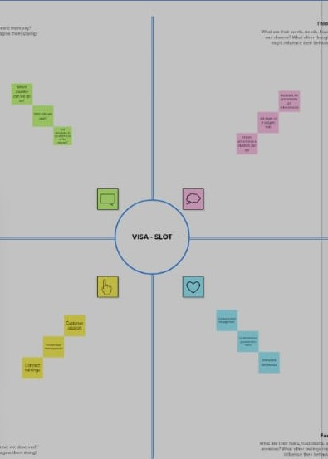

## 2.2.Brainstorm and idea prioritization

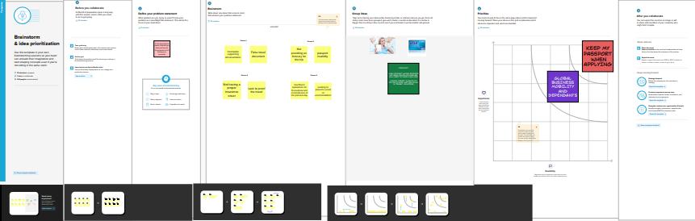

# 3.RESULT

## 3.1.Data model

|  |  |  |
| --- | --- | --- |
| **Object Name** | **Field in the object** | |
| **passport** | Field label | Data type |
| Full name | Text |
| Passport  Number | Number |
| Contact  Number | Number |
| Permananet  Address | Number |
| **Visa slot** | location | Text |
| Time | Number |
| Passport  Number | Master |
| Visa slot  Number | Number |
|  | Payment  Mode | Number |
| **payment** | Card  Number | Number |
| Transaction  Id | Auto  Number |
| Cancel  Transaction | Text |
| Visa slot  Number | Master |
| **Reschedule/ cancel** | Passport  Number | Master |
| Location | Text |
| Time | Number |
| Cancel | Text |
| Status | Text |

## 3.2.Activity Screen Shots

* **Home page of Sales force Account**

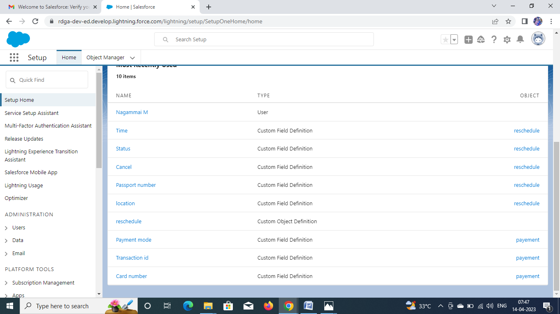

* **Custom Object**

1. **Passport**

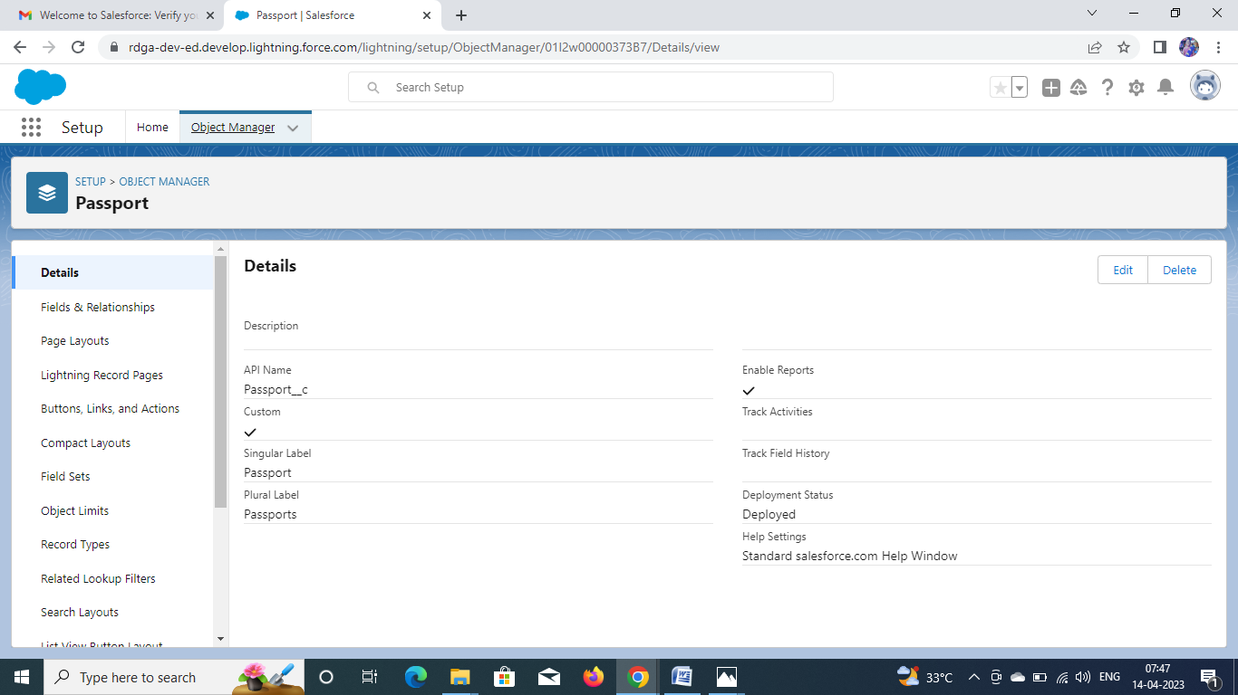

2.**Visa Slot**

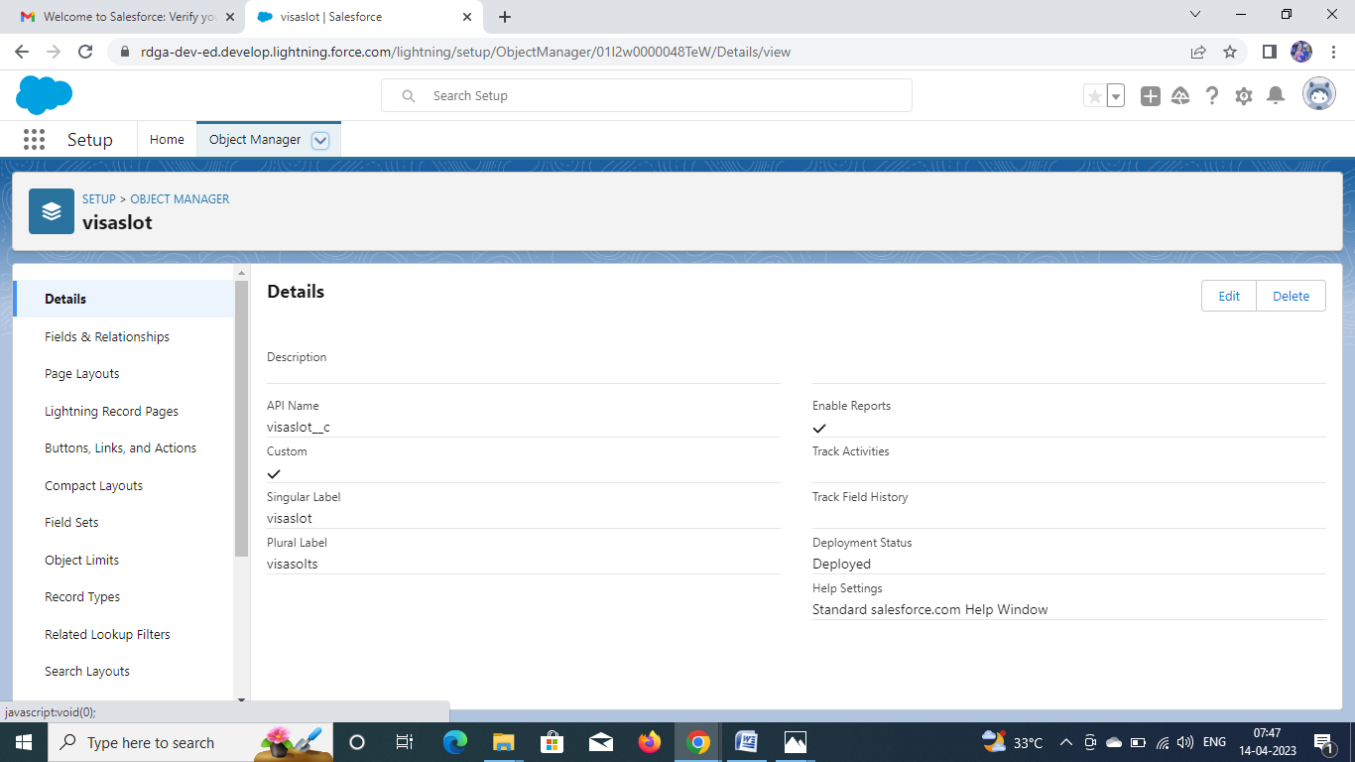

3.**payment**

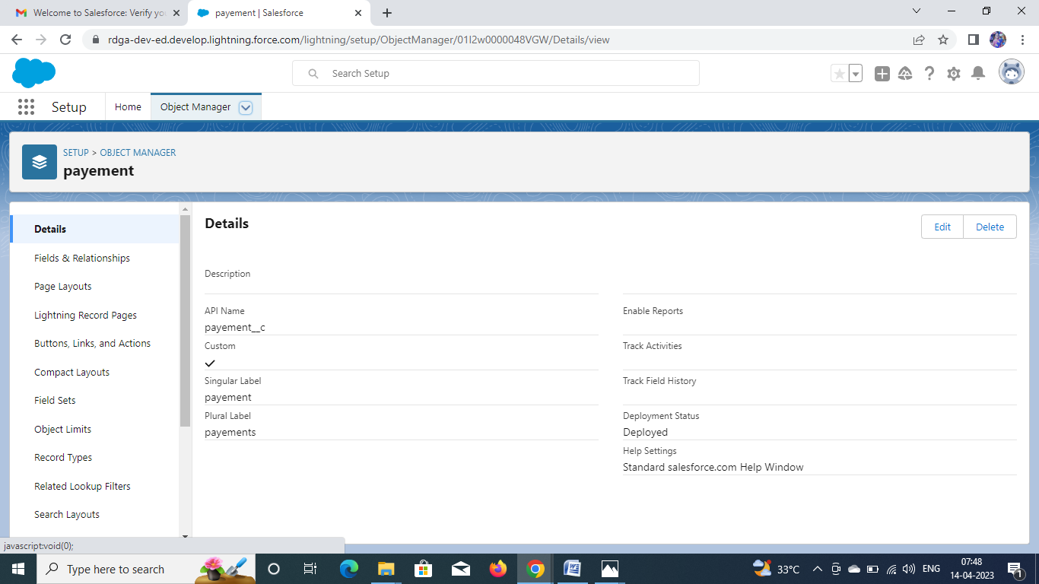

4.**Reschedule/cancel**

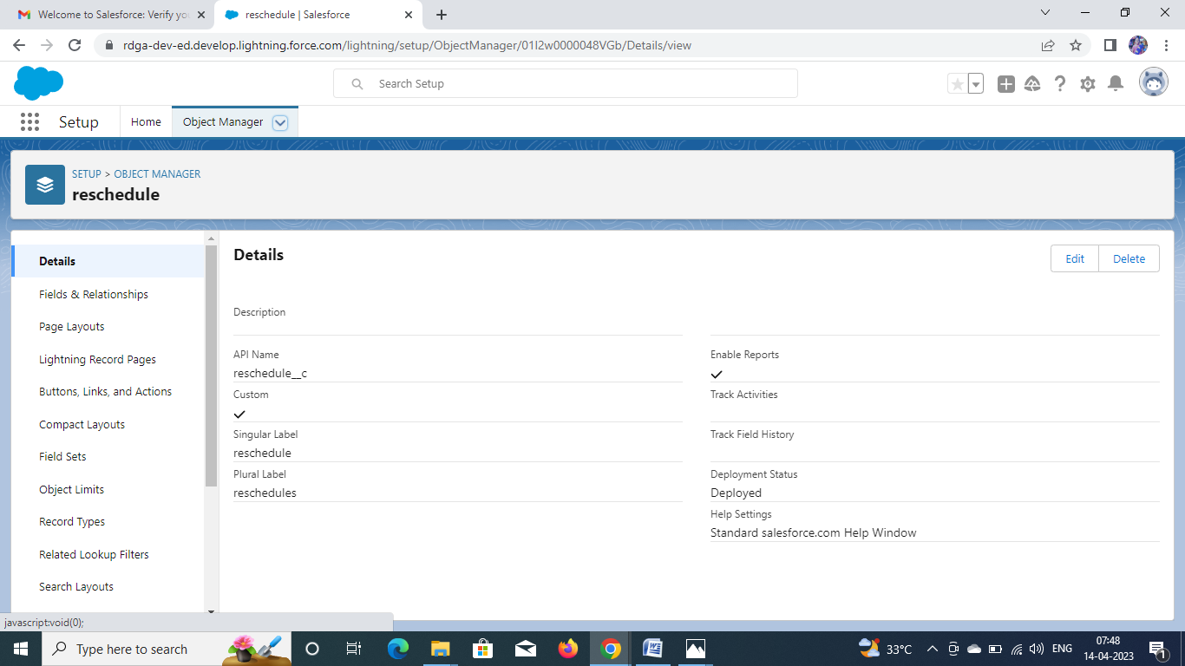

**5.Users**

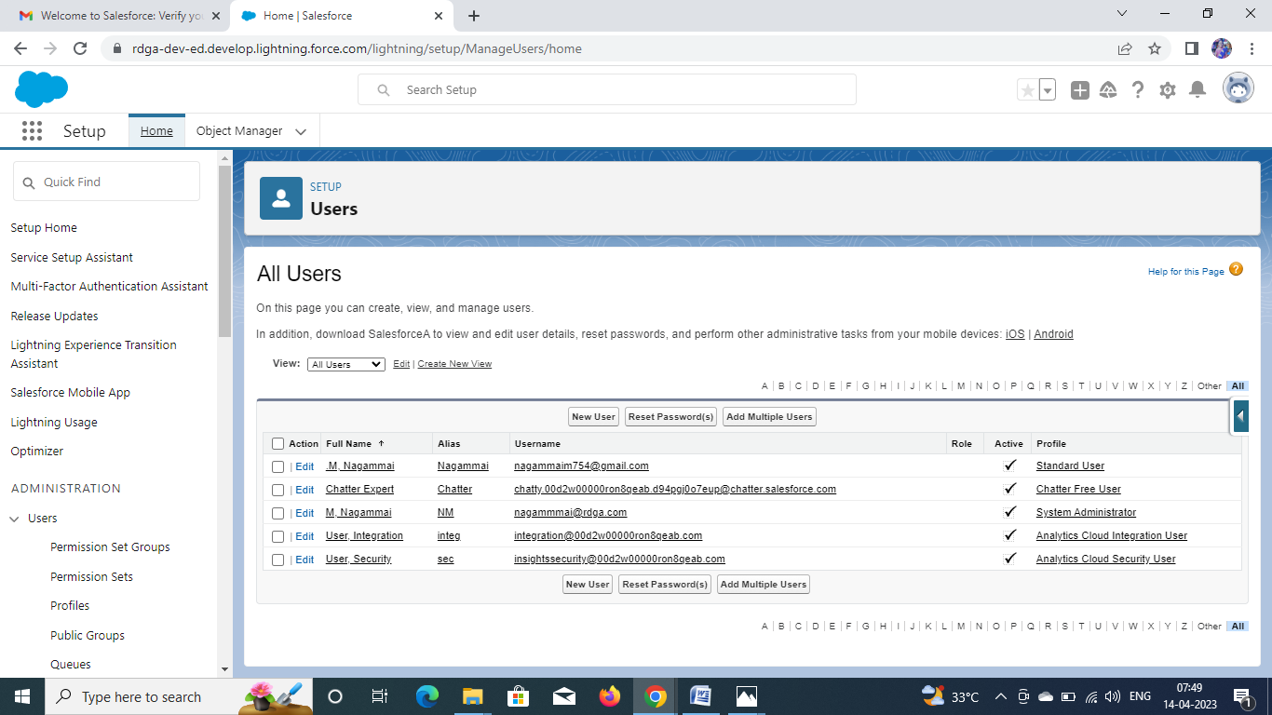

**6.Reports**

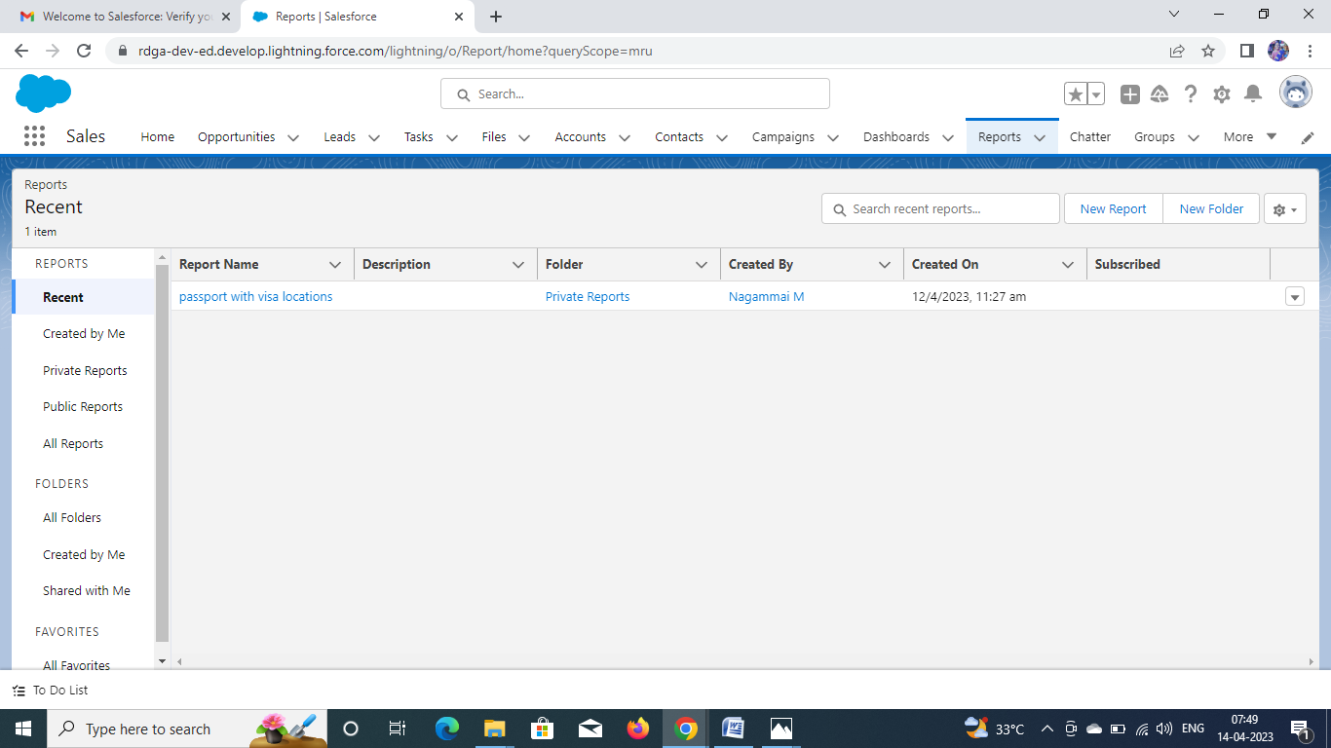

**7.Dashboards**

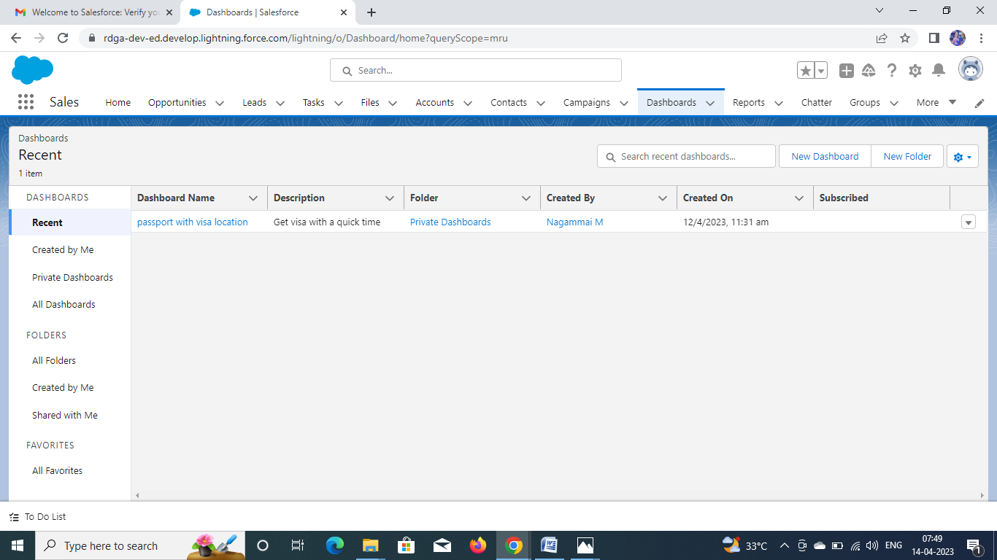

# 4.Trailhead Profile Public URL

* **Team Leader - https://trailblazer.me/id/nagam104**
* **Team Member 1 -** [**https://trailblazer.me/id/sulaihafathima15**](https://trailblazer.me/id/sulaihafathima15)
* **Team Member 2 -** [**https://trailblazer.me/id/gkaviyamathavi**](https://trailblazer.me/id/gkaviyamathavi)
* **Team Member 3 -** [**https://trailblazer.me/id/bhavanipk02**](https://trailblazer.me/id/bhavanipk02)

# 5.Advantages & Disadvantages

|  |  |
| --- | --- |
| Visa credit card is one of the most popular credit cards in the world. | Initial costs of installing the system is high. |
| A credit card has become an indispensable part of our lives, with its ease of use and consular pay-back options. | Booking agencies on the high street may close down due to lack of customers. |
| Visa card is among the most widely used credit cards in the world which offers 24/7 assistance in case of on emergence. | There is no personal service like at a high street travel agent. |

# 6.Application

The **visa slot** may helps to bearer to legally enter a foreign country. A visa slot management project is a system that is used to track and manage the availability of visa slots, which are appointments that are required for certain visa applications. It might be used by a government agency or a visa processing center to schedule and manage appointments with applicants.

# 7.Conclusion

The project “visa slot management system” has been designed and integrating features of all the software components used have developed it with the help of definitely reduce the human efforts and make the task for used customer and administrator earlier.

# 8.Future Scope

It can be summarized that the future scope of the project circles around maintaining regarding.

* We can develop more advance sources enhances to applying a visa more simple.
* We will access the process on online servers to applying it on worldwids.
* In future, it is the number one app of booking a visa. We will censerily working on it.

The above mentioned points are the enhancements which can be the to increase the Applicability and usage of this project . Here we can maintain the recards of event and booking. We hope that the project will serve its purpose for which it is develop there by underlining success of process.